|  |  |  |
| --- | --- | --- |
| f |  |  |
| **Benha University** |  | **Faculty of Computers & Artificial Intelligence** |

**Supermarket Management System**

**In**

**Information system**

**by**

|  |  |
| --- | --- |
| (**Section 12**) علي شعبان محمد شعبان | (Section 12)عمر ماجد جلال الدين علي |
| (**Section 5**)أيه السيد على إبراهيم منصور | (Section 12) عمر خالد محمود علي |
| على محمد احمد عبدالراضى سكشن 12 | على السيد محمود الجزار سكشن 12 |

**Supervised by**

# Ahmed Tawfik

Table of Contents

1. Introduction *(Heading 1)* 1

2. Content 1

*2.1* *Subtitle 1 (Heading 2)* 1

*2.3* *Equations* 2

3. Conclusion 3

# Introduction *(Heading 1)*

# This project we will take about supermarket management system.

**The Project Supermarket Management System deals with the automation of supermarket. It includesboth sales and purchase of items. The project Supermarket Management System is developed with the objective of making the system reliable, easier, fast, and more informative. There is a lot of reason forthe introduction of this project. In the manual System, there are number of ineffciencies that asalesperson faces. Large records-books have to be maintained where relevant and irrelevant information has to be stored which is very untidy and clumsy process. But our System reduces paper works. On theother hand, there are many inherent problems that exist in any manual system. Usually, they lack efficiency. Less efficiency has a great impact on the productivity of any human being keeping the data up-to-date.**

**This project contains ten sections, each section expresses the section in the supermarket** . **This project contains six sections, each section expresses the section in the supermarket**. **And in our program have ten frame .**

# Content

1. **Sections:**
2. **Bakery section**
3. **darly section**
4. **meat section**
5. **canned section**
6. **fruit section**
7. **vegetables section**
8. **frames:**
9. **main form**
10. **login form**
11. **new account form**
12. **Bakery section**
13. **darly section**
14. **meat section**
15. **canned section**
16. **fruit section**
17. **vegetables section**
18. **shopping cart**
19. **Frame shape :**
20. **Graphical user interface, application

    Description automatically generatedMain form**
21. **Login form**

1. **new account form**

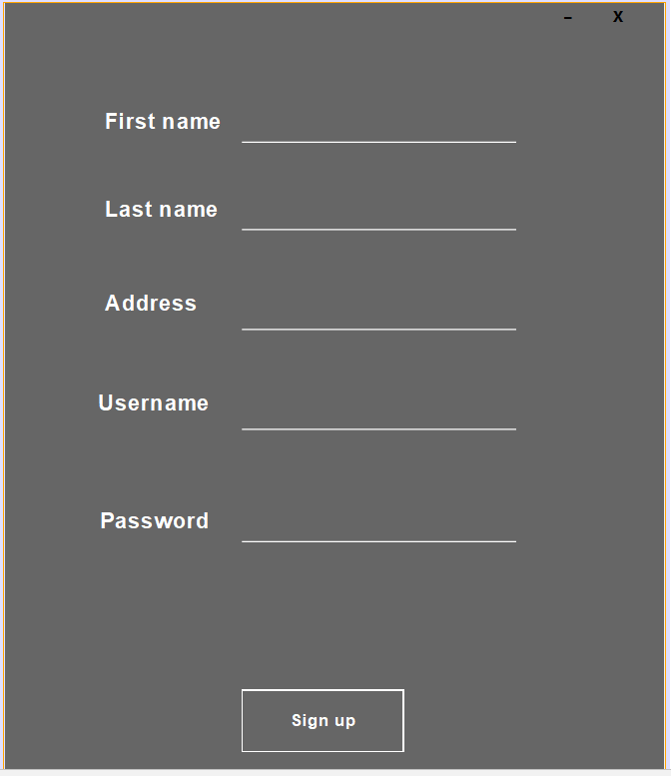

1. **Bakery section**

1. 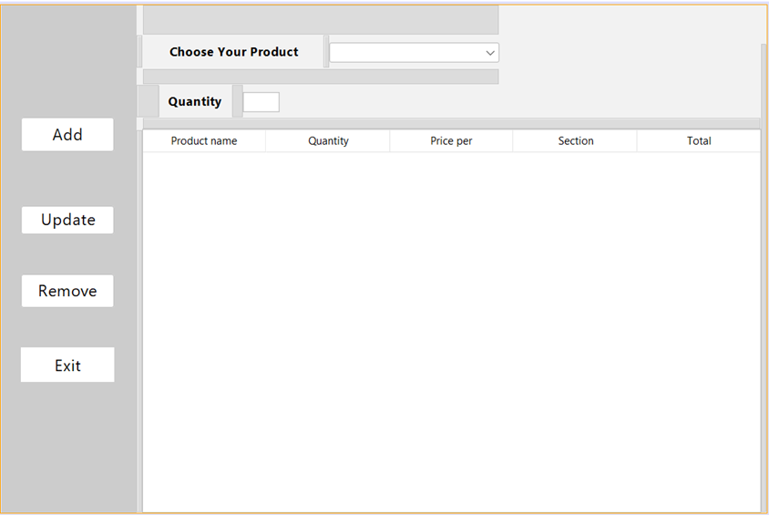**darly section**
2. **Graphical user interface, application

   Description automatically generatedmeat section**
3. 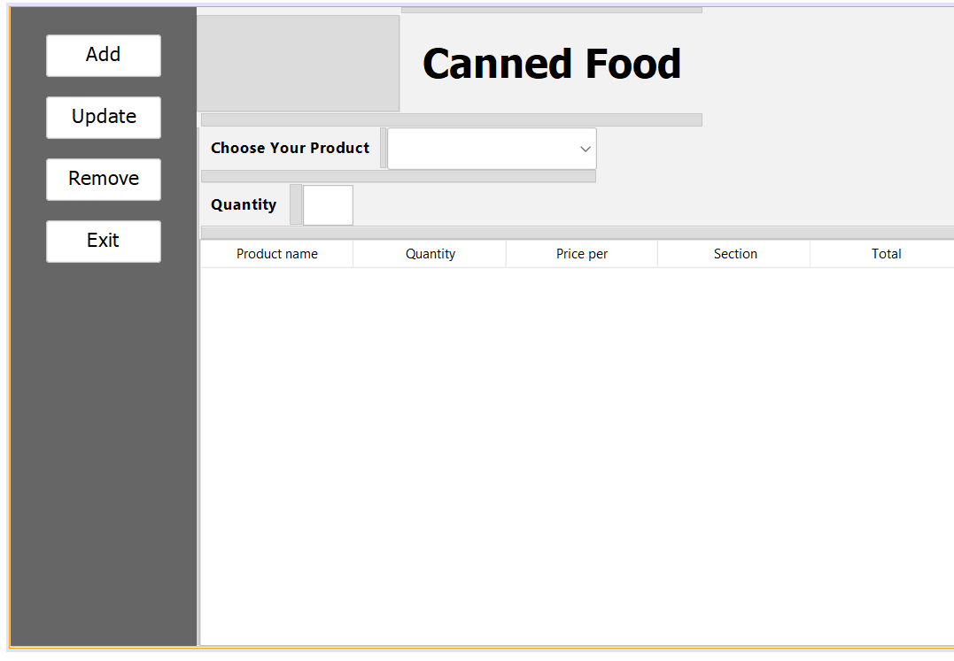**canned section**
4. **Graphical user interface, application

   Description automatically generatedfruit section**
5. **Graphical user interface, application

   Description automatically generatedvegetables section**
6. **Graphical user interface, application, table

   Description automatically generatedshopping cart**

**Steps :**

**First the customer will enter in our system will make login if he/she have account and if he /she don't have an account will do sign up and make an new account**

**Second , go to the section he needs to buy the product he need and make order to send the product to him**

# Conclusion

**Our application very easy to buy product and making shopping easy .That we tried to make a system that provides the best service to our clients .**